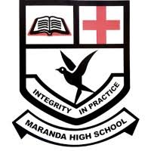

MARANDA 2025 KCSE PREDICTION
EXPECTED EXAM 1
ART AND DESIGN
442/1
PAPER 1 (THEORY)
TIME: 1½ HOURS

NAME……………………………………………………………………………………..
SCHOOL……………………………………………… SIGN………………………..
INDEX NO……………………………………………. ADM NO……………………

Kenya Certificate of Secondary Education.

INSTRUCTIONS TO CANDIDATES
- Write your name and index number in the spaces provided above
- Sign and write the date of the examination in the spaces provided above.
- This question paper consists of three sections A, B and C.
- Answer all questions in section A and B.
- Answer any one question in section C
- Answers to all the questions must be written in the spaces provided in this booklet.
- Do not remove any paper from this booklet.

For Official Use Only
Section | Question | Maximum score | Score
A | 1 | 20
B | 2 | 05
 | 3 | 05
 | 4 | 05
 | 5 | 05
 | 6 | 05
C | 7, 8, 9 | 15
Max. Score |  | 60

SECTION A (20 MARKS)
Answer ALL questions in this section.
1. a)Define the term Subject Matter as used in art? (2mks)
…………………………………………………………………………………………………………
…………………………………………………………………………………………………………
…………………………………………………………………………………………………………

b) What is a highlight with reference to an artwork (1mk)
…………………………………………………………………………………………………………
…………………………………………………………………………………………………………

c) Study the illustration below and answer the following questions.
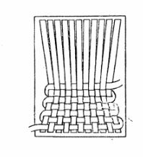
i) Name the weaving defect portrayed (1mk)
…………………………………………………………………………………………………………

ii) What causes the above defect? (1mk)
…………………………………………………………………………………………………………
…………………………………………………………………………………………………………

d) Give two characteristics of a mosaic work (2mks)
…………………………………………………………………………………………………………
…………………………………………………………………………………………………………

e) What does the term “Primer “stand for as used in painting? (2mks)
…………………………………………………………………………………………………………
…………………………………………………………………………………………………………
…………………………………………………………………………………………………………

f) Why is ironing out of wax not recommended in fabrics to be used for dresses? (1mk)
…………………………………………………………………………………………………………
…………………………………………………………………………………………………………

g) Name the ceramic technique used to produce several identical clay articles. (1mk)
…………………………………………………………………………………………………………
…………………………………………………………………………………………………………

h) In Art, what do we mean by the term Balance (1mk)
…………………………………………………………………………………………………………
…………………………………………………………………………………………………………

i)Identify the tool illustrated below and state its role in printmaking. (2mks)

j) Explain the term Simultaneous contrast. (2mks)
…………………………………………………………………………………………………………
…………………………………………………………………………………………………………
…………………………………………………………………………………………………………

k) Outline two differences between collage and montage. (2mks)
…………………………………………………………………………………………………………
…………………………………………………………………………………………………………
…………………………………………………………………………………………………………
…………………………………………………………………………………………………………

l) In the space below draw the typographical illustration of any uppercase alphabet to show; (2mks)

(i)SERIF (ii) SANSERIF

SECTION B ( 25 MARKS)
Answer ALL questions in this section in the spaces provided
2. study the art work below

a) Identify the kind of art work? (1mk)
…………………………………………………………………………………………………………

b)Why is it necessary to frame such an art work? (2mks)
…………………………………………………………………………………………………………
…………………………………………………………………………………………………………
…………………………………………………………………………………………………………

c)Identify two elements portrayed in the art work. (2mks)
…………………………………………………………………………………………………………
…………………………………………………………………………………………………………

3. i) What is a letterhead? (1mk)
…………………………………………………………………………………………………………
…………………………………………………………………………………………………………

ii) Name and explain four components of a letterhead (4mks)
…………………………………………………………………………………………………………
…………………………………………………………………………………………………………
…………………………………………………………………………………………………………
…………………………………………………………………………………………………………
…………………………………………………………………………………………………………

4. a) Identify the technique below and the pattern created in fabric decoration. (1mk)
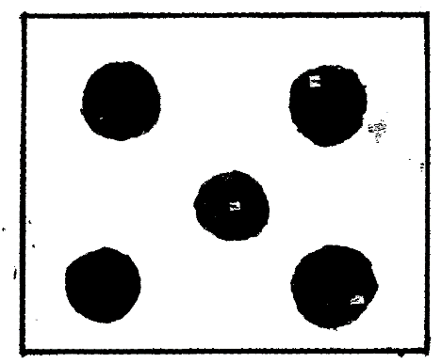
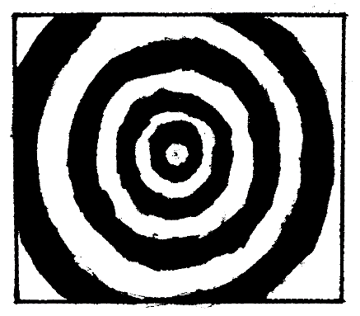

(i)………………………………………. (ii)………………………………………

(b) Briefly explain how each of the end results were achieved. (4mks)
…………………………………………………………………………………………………………
…………………………………………………………………………………………………………
…………………………………………………………………………………………………………
…………………………………………………………………………………………………………
…………………………………………………………………………………………………………

5. a) Differentiate between ornaments and jewellery. (1mk)
…………………………………………………………………………………………………………
…………………………………………………………………………………………………………

b) Outline four factors to consider when designing ornaments. (4mks)
…………………………………………………………………………………………………………
…………………………………………………………………………………………………………
…………………………………………………………………………………………………………
…………………………………………………………………………………………………………
…………………………………………………………………………………………………………

6. Using the hatching technique, create three dimensional effects on the still life composition below. (5mks)

SECTION C ( 15 MARKS)
Answer any one question from this section
Write your answers in the spaces provided after questions 9.
7. a) What is a Motif. (1mk)
b) Explain two differences between Bock and Stencil techniques of printing. (4mks)
c) Using a motif derived from a flower as an example, describe the process of producing a half- drop repeat using block printing technique. (10mks)

8. a) State one function of grog. (2mks)
b) Explain the meaning of the term ‘vitrification’ as a property of clay. (2mks)
c) Identify any four hand building techniques used in pottery making. (2mks)
d) With the help of illustrations explain the process used in any three of the above identified techniques. (9mks)

9. a) Define the term ‘design brief’ (1mk)
b) What is a caption? (2mks)
c) Define the term ‘animated cartoons’. (2mks)
d) Discuss the graphic design problem solving process (10mks)

